Geometric Construction of Roots of Quadratic Equation
A quadratic equation
ax² + bx + c = 0,
witrh the leading coefficient a ≠ 0, has two roots that may be real - equal or different - or complex. The roots can be found from the quadratic formula:
x_{1,2} = (-b ± √b² - 4ac) / 2a,
In addition to the four arithmetic operations, the formula includes a square root. This is exactly the kind of operations that produce constructible numbers from constructible numbers. (By being "constructible" we mean a length (of a straight line) segment that could be constructed by straightedge and compass, given a unit length.) In fact, Descartes used this example to introduce his ideas of analytic geometry.
I came across a a generalization of Descartes' construction in an old translation (1910) of the classic The Theory of Geometric Constructions by August Adler (1863-1923).
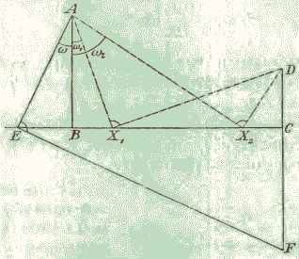
Following Adler, in order to solve the quadratic equation, form a broken right-angled line ABCD, with AB = a, BC = b, and CD = c taking account of the signs of the coefficients. For example, with c < 0, the segments AB and CD should be pointing in different directions:
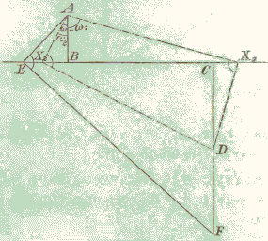
Choose point E on BC and let ω be the ∠EAB. Introduce x = tan ω and find F on CD to make ∠AEF right. Then
BE = ax,
CE = ax + b,
CF = (ax + b)x,
DF = (ax + b)x + c.
It follows that DF = ax² + bx + c and, in case, F = D, x is naturally a solution to the quadratic equation ax² + bx + c = 0. The way to find a solution x is to locate point X on BC for which ∠AXD = 90°. How do you find such an X? Curiously, Adler suggest a neusis construction of sorts: use two rules attached at a right angle to make two perpendicular lines pass through A and D with a vertex on BC.
Except for the last part, the construction is immanently appealing. This is, of course, a graphical implementation of Horner's scheme and is easily extended to evaluating graphically polynomials of any degree greater than 1.
As to the solving of quadratic equations, the simple way of locating the required positions X with ∠AXD = 90°, is by drawing a circle on AD as diameter and finding where it intersects (if at all) the line BC. This is how it is done in the applet bellow. In the low left corner of the applet, there are three sliders each housing three points - yellow, red and blue (all draggable). The first two indicate the positions of 0 and 1 and thus the unit of measurement used by the slider. The distance of the blue dot to the yellow relative to the distance from the red one to the yellow, is given to the right of the slider. The sliders are numbered 0, 1, 2, corresponding to the coefficients a, b, c.

