Appendix D
College of Micronesia-FSM

COURSE MODIFICATION REQUEST

VEE200 Op Amps Division of Technology & Trade
Course Number & Title Division

VEE224 Video Systems & Product Servicing Division of Technology & Trade
Recommended Course Number & Title Division

New Course Objectives: This course is designed to provide students with the opportunity to apply the principles of operation for video system products including service and repair procedures of various products. Students will experience hands-on activities such as fault diagnosis, cost estimates, parts testing and replacement, reassembling and testing of repaired video systems and products following manufacturer and industry standards.

New Course Description: This course is designed to provide students with the knowledge and experience in the principles of operating, diagramming, circuit tracing, mechanical assembly and disassembly, maintenance and troubleshooting procedure of television, VCR, CD, DVD and other related electronic products.

Justification for Revising the Course:

The proposed modification will incorporate contents of existing course (VEE200) in operational amplifiers and the required knowledge and skills in radio communications (as part of the requirement in the old program) Emphasis will be on the required knowledge and skills in the operations and servicing of video systems, such as TV, computer monitor, VCR, DVD players, and compact disc devices.

The modification will also be an improvement to the program in meeting the needs required by the community in the maintenance and repair of electronic consumer products.

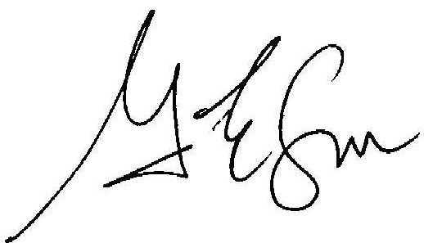

_____________________________________ ___Sept. 29, 2006
Chairperson, Division of Technology & Trade Date

_____________________________________ _________________
Chairperson, Curriculum Committee Date

_____________________________________ __________________
President, COM-FSM Date

Official Use Only
New Course Number & Title:
____________________________________________________________

