Appendix A
College of Micronesia-FSM

COURSE MODIFICATION REQUEST

VEE220 Microprocessor I Division of Tech. & Trade
Course Number & Title Division

VEE223 PC Hardware & Repair Division of Tech & Trade
Recommended Course Number & Title Division

New Course Objectives: Refer to learning outcomes stated in the attached course outline.

New Course Description: Refer to the attached course outline

Justification for Revising the Course:

The modification will include the fundamentals of the microprocessor and emphasize the applications of microprocessor on how it used on personal computers.

Also, students will learn how to assemble, install, configure, and troubleshoot a personal computer.

Program improvement to meet the required needs of the community to maintain and repair personal computers
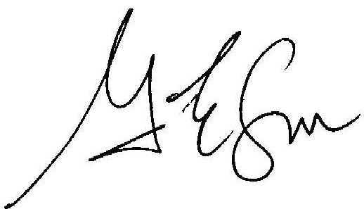
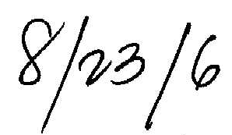

_____________________________________ __________________
Chairperson, Division of Technology & Trade Date

_____________________________________ __________________
Chairperson, Curriculum Committee Date

_____________________________________ __________________
President, COM-FSM Date

Official Use Only
New Course Number & Title:
____________________________________________________________

