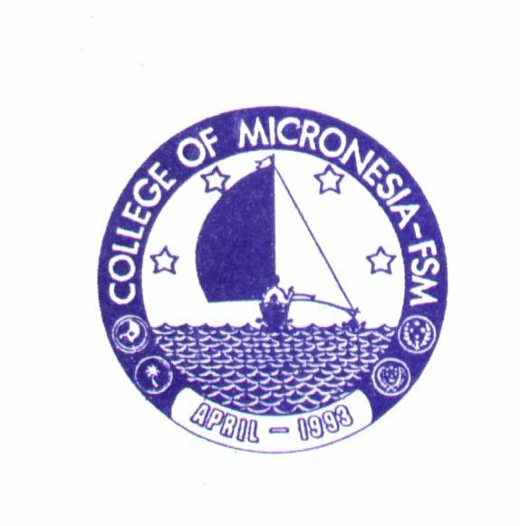

COLLEGE OF MICRONESIA

Chuuk Campus
Box 879 Weno, Chuuk
Federated States of Micronesia 96942
(691) 330-2689 Fax (691) 330-2740

Date : July 31, 2026

To : Jean Thoulag,
Karen Simion

From : Richmond, Vocational Ed, Chuuk

Subject : Computer Graphics Assessment Matrix

Jean and Karen,

I have been trying to come up with the PLO’s for the Computer Graphics certificate program that I submitted earlier this year. I have also attempted to make a course alignment matrix for the courses suggested for the certificate program. Below please find the results of this effort.

Intro to CG: SLO’s

- Set up and correctly use a simple digital camera
- Take digital pictures
- Download in to computer photo program digital images from a digital camera
- Manipulate, crop, and retouch digital images
- Import images into a graphic layout
- Use various templates to generate publishable flatwork (e.g. stationery, T-Shirt Transfers etc.)
- Prepare a personal portfolio of visual work

Digital Photography SLO’s

- Take digital pictures,( Advanced activities and practice)
- Download in to computer photo program digital images from a digital camera (Advanced activities and practice)
- Take digital pictures (Advanced activities and practice)
- Manipulate, crop, and retouch digital images. (Advanced activities and practice)
- Design and prepare images for photo essays
- Draw or sketch items for scanning purposes
- Prepare a personal portfolio of visual work

Publishing and flatwork SLO”s

- Open Microsoft Publisher
- Identify the parts of the Microsoft Publisher window
- Add tool bars and other graphic aides to the project window
- Import images or clip art to project window
- Add layers, and shapes, outlines, shadows and other design elements to project items
- Add text to project window
- Save project in personal file
- Print project

PowerPoint SLO’s

- Open Microsoft PowerPoint (version 2003 or later)
- Identify the parts of the Microsoft Publisher window
- Add tool bars and other graphic aides to the project window
- Import images, sound, or video clips to project
- Add layers, and shapes, outlines, shadows and other design elements to project items
- Add text to project window
- Save project in personal file
- Present Project

Practicum SLO’s

- Contact a sponsoring agency
- Develop plan of action
- Obtain necessary images
- Prepare layouts or story board
- Independent product development

Program Learning Objectives

The PLO’s for the Computer Graphics Certificate can be divided into two groups
- Hardware related skills. The overall objective of this certificate program is to enable the successful student to gain competency in the use of computers, digital cameras, scanners and other peripheral equipment.
- Artistic design and personal self expression skills are expected to stem from the use of the computer and related equipment and through specific assignments and class activities aimed at sharpening the students awareness of both image selection and composition. Also the class activities are to provide experience in developing layout design and image sequencing skills.
The successful student will be able to:

- Operate a computer and appropriate programs for computer graphics activities
- Operate Digital cameras and other equipment for image capture
- Print or show projects that demonstrate skills in the computer graphics activities
- Develop layouts or slide sequences that address specific needs of an audience or client.
- Compile a personal portfolio of photographic images, drawings, and projects for use in future computer-based activities.

The Alignment Matrix for this Certificate program follows:

Course Name | PLO #1 | PLO #2 | PLO #3 | PLO #4 | PLO #5
Intro to C.G | I | I | I |  | I
Digital Photography | P | P | P | I | P
Publishing and Flatwork | P |  | P | P | P
PowerPoint | P | P | P | P | P
Practicum | C | C | C | C | C

The alignment of the course SLO’s and the PLO’s appear to be in the proper order with possible exception of the expectation that there will be competency in all of the PLO’s though the practicum course. It is unclear whether or not a student will be able to obtain a sufficient number of images to be able to effectively produce many projects. The well motivated student will be able to do this assuming that sufficient time in and out of class is devoted to the development of the personal ability to see. This skill can only be honed through much practice and feedback from others. Until this program is presented it is difficult to predict the level of acceptance of the program by the students and its ability to motivate the participants.

Please review the above and provide comments and feedback.

Thank you for your interest and assistance.

Stephen Richmond
Voc Ed Chuuk

