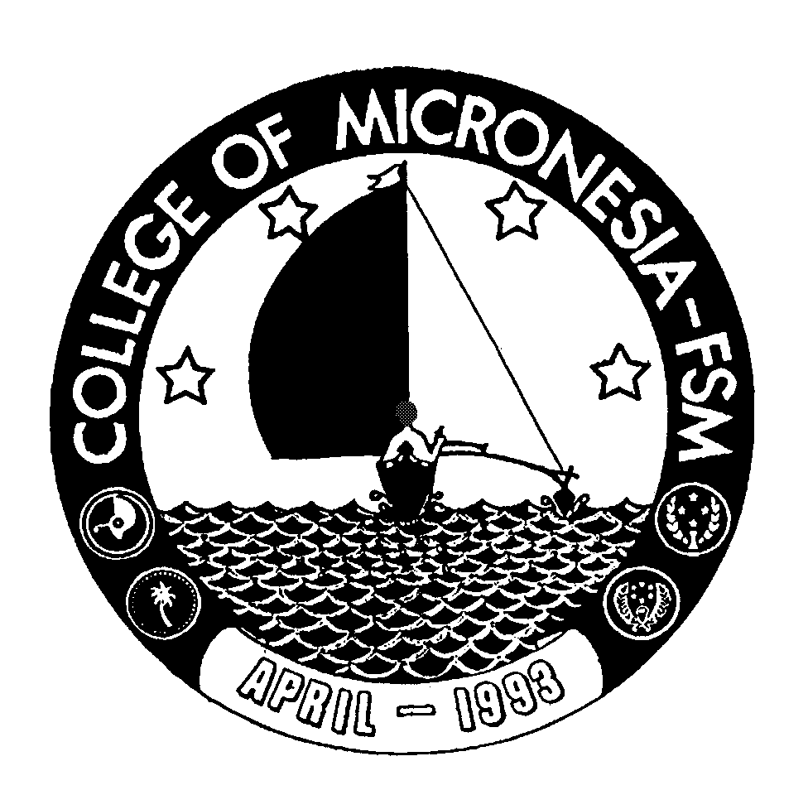 Office of the

College of Micronesia-FSM

P. O. Box 159, Kolonia, Pohnpei

Federated States of Micronesia 96941
Phone: (691)320-2481 Ext: 127 Fax: (691)320-2479 E-mail: thoulagj@comfsm.fm
Vice President for Instructional Affairs

January 24, 2006

MEMORANDUM

TO: President, COM-FSM DRAFT

FROM: Chairperson, Curriculum Committee_______

SUBJECT: Minutes of Committee Meeting—01/24/06

PRESENT: Jean Thoulag, Karen Simion, Jonathan Gourlay, Dana Leeling, Anwar Jahan, Benson Moses, Arleen Dumantay, Rachel Hollingsworth, Maria Dison, Gardner Edgar, Charles Musana and Quly Alex

The meeting was called to order at 11:40 a.m. by Jean Thoulag, Chairperson.

I. Review and Approval of Minutes

The minutes of December 08, 2005 were reviewed and recommended for approval.

Old Business

- Last Semester GPA requirement proposed change
- Communication Protocols with State Campuses
- Goal One proposed revision—Assessment Framework

The Committee agreed to present the above items at the campus wide meeting scheduled for next week, January 30 to February 3rd.

III. New Business

Program Modifications

- AA/Liberal Arts in Health Careers Opportunity Program— In order to ensure the nutrition program learning outcome is met, better focus the program, and to reduce the number of credit hours to more manageable level for a two year program, the committee approved the following modifications/changes for the HCOP program. Drop the four credits science elective requirement that students take; add as requirement SC 112 Nutrition; drop the MS 101 Algebra and Trigonometry requirement from the major. Change the six credits to three credits math elective requirement under the major requirements to read “One of the following: MS 101, MS 150 or MS 152.” Total credits 66.

General Education Core Math Requirement— Recommended for approval to adopt changes to change math requirement for the General Education Core to read: Any 100 level or above math course.

Agriculture Courses meeting the General Education Core Science Requirement—Agriculture courses to meet lab/non lab science requirement. The following Agriculture courses are the only Agriculture courses identified and recommended for approval to fulfill the general education core requirements for science with lab and non-lab science: AG 101, AG 110 and AG 140.

Course Outlines

Recommended for approval:
- MS 090 Conceptual Math (revised)
- EN 209 Introduction to Religion

Recommended for approval with modifications:
- VBM 102 Building Maintenance
- VWE 115 General Welding
- VEM 114 Refrigeration II
- VTE 261 Fiber Optics Installation
Gardner to submit corrected copies to VPIA’s office.

Tabled for next meeting:
- ED/RS 302 Introduction to Related Services (3 credits)
- ED/RS 304 Intermediate Related Services (3 credits)
- ED/RS 306 Related Services Practicum I (3 credits)
- ED/RS 311 Related Services Practicum II (3 credits)
- ED/RS 313 (Related Services Practicum III (3 credits)

- Others

First day of class/week absence policy—developmental classes (first reading)
To continue discussion next meeting.

Accredited by the Western Association of Schools and Colleges

