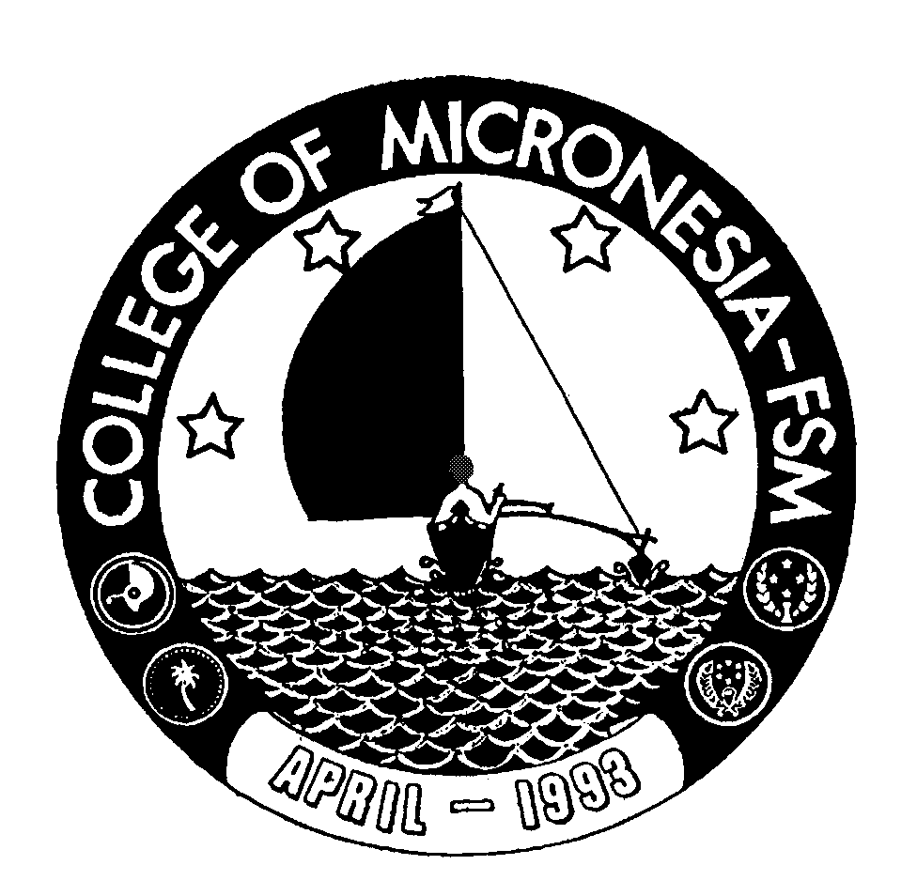 Office of the

College of Micronesia-FSM

P. O. Box 159, Kolonia, Pohnpei

Federated States of Micronesia 96941
Phone: (691)320-2481 Ext: 127 Fax: (691)320-2479 E-mail: thoulagj@comfsm.fm
Vice President for Instructional Affairs

April 25, 2006

MEMORANDUM

TO: President, COM-FSM DRAFT

FROM: Chairperson, Curriculum Committee_______

SUBJECT: Minutes of Committee Meeting—04/25/06

PRESENT: Jean Thoulag (Chair), Dana Lee Ling, Charles Musana, Jonathan Gourlay, Mariana Ben-Dereas, Anwar Jahan, Karen Simion, Rachel Hollingsworth and Gardner Edgar.

The meeting, held in the Board Conference Room, was called to order at 11:45 am. The Chairman welcomed members present and introduced the agenda - which had already been distributed:

I. OLD BUSINESS

- Finalizing wording for ESL 088 course modification
Following e-mail communication among members of the curriculum committee and Division of Languages and Literature faculty and chair, the final wording of the section in question on the ESL088 course modification is: “One novel from the 6-8 graded reading level of the Townsend Press library series to be selected by the division chair in consultation with the ESL/developmental faculty." A motion was made to approve the ESL 088 course modification with the above wording and the motion was passed unanimously.

- Re-certification of part-time instructors
Discussion continued on re-certification of part-time instructors. The concerns raised:
- No clear definition of “part-time” faculty
- Student evaluation data—should not be the basis for evaluating an instructor for re-certification purposes. [Some members thought that since they were not required for full-time faculty, they shouldn’t be for part-time faculty either; others thought that student evaluations need to be studied/analyzed over time before they can be adopted as a formal faculty evaluation tool; yet others thought student evaluations should be a consideration in the re-certification of a part-time instructor, albeit not the major consideration]
- Staff development—should this be extended to some part-time instructors, especially those who have continued to teach at the College year after year? Would calling them “adjunct” faculty make them eligible?

________________________________________________________________________
Accredited by the Western Association of Schools and Colleges

A small working group was formed to research the issues and submit a recommendation(s) to the committee next time. The group includes: Karen Simion, Jonathan Gourlay, and Maria Dison (representing state campus Instructional Coordinators).

- FSM Nursing Program modifications

The program changes were discussed:
- 85 credits total multi-segment program
- Encompasses Nursing Assistant (6 credits); Practical Nurse Certificate (37.5 credits), and; AS in Applied Nursing (41.5 credits.
Issues:
- The program needs to have one humanities and one social science requirement added. This would raise the total credits to 91.
- The suggested semester loads are too heavy (19 credits; 18 credits; etc…) for students who are likely to be mostly remedial.
- There is an overlap between this program and the already approved Community Health program in some areas. Could some of the courses be combined into joint Nursing/Community Health courses?
- The 1st semester Nursing Assistant program assumes students will be placed into the ESL courses (089, 099) and into MS095. However, while such placement is done at the beginning of the semester, nursing students will need to know they are “nursing” students upon admission – sometimes long before their first semester begins.
Suggestions/Recommendations:
- Reduce NU 106a an b from 1.5 to 1 credit each.
- Modify NU 102 (say from 6 credits downwards)
- Replace EN/CO 205 with a “humanities” course e.g. Poetry.

It was agreed that modifications would be made and electronically circulated to members for comment and/or approval. The Committee chair stressed that the FSM government wants the college to develop the program and that the Board would like to consider the program at their May meeting.

II. NEW BUSINESS

1. ESS 102s Softball
The ESS 102s course outline was introduced for first reading. It was recommended that the outline be distributed to state campuses for input and be presented for approval at the next meeting.

- MS 096 Elementary Algebra
The MS 096 course outline was introduced for first reading. It was recommended that the outline be presented for approval at the next meeting.

III. INFORMATION SHARING

The Chair shared information regarding her recent trip to Hawaii:
- Her visits to Kapiolani Community College; her meeting with Collette Higgins and their discussion of Learning Communities, team-teaching and service-learning.
- The PPEC meeting in Hawaii and a possible grant to fund institutional capacity building – leadership.
- Feedback from Dr. Sakai at UH-Hilo regarding our former students.
- Meeting with Jim Mellon at UH-Hilo. He has a course equivalency matrix for UHH courses vs. COM-FSM courses starting from CCM days till today.

The chair promised to have the above information circulated in her trip report.

The meeting was adjourned at 1:30 pm.

