Curriculum Handbook

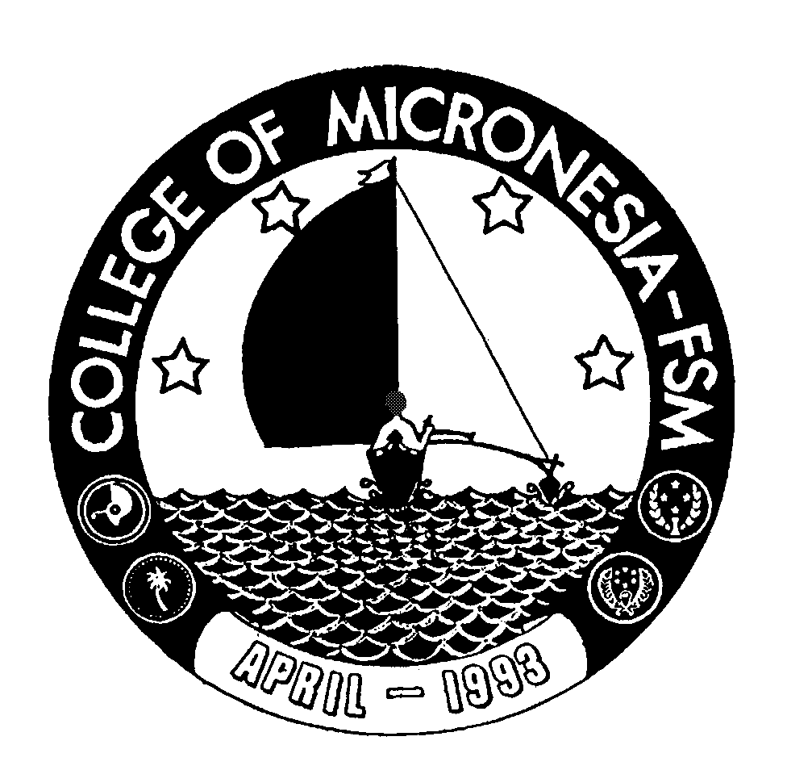

College of Micronesia-FSM

School Year 2005-2006

